**Guided Solution for Tutorial 4**

**Question 5**

1. Remove RL

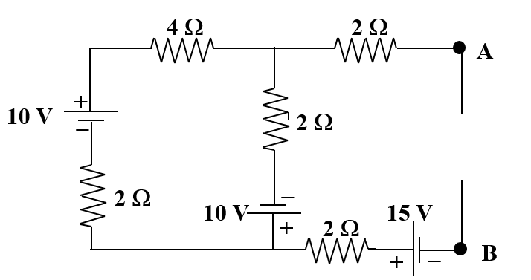

Figure 1

2. Short AB and calculate IN



I2

I1

3. Draw 2 loop currents. Write down the mesh current equation matrix.

4.

5. Solve for I2 use the determinant method. IN = I2

6. To find RN replace all the voltage sources in Figure 1 with a short circuit.

7. Calculate the equivalent resistance across AB

8. Draw the equivalent circuit and connect RL across AB

9. Apply current divider rule to find IL